AWS S3 Tasks

Task 1: Create an S3 Bucket and Upload Some Objects
Purpose
Create an Amazon S3 bucket and upload files into it for storage.

Step 1: Login to AWS
Login to the AWS Management Console.
Search S3 in the search bar.
Click Amazon S3.

Step 2: Create Bucket
Click
Create bucket

Fill the following details
Field | Value
Bucket Name | sarfaraz-s3-bucket-001 (must be globally unique)
AWS Region | us-east-1
Object Ownership | ACLs Disabled (Default)
Block Public Access | Keep Default Enabled
Leave remaining settings as default.
Click
Create bucket

Bucket will be created successfully.
📸 Evidence Screenshot 2
- Bucket created successfully
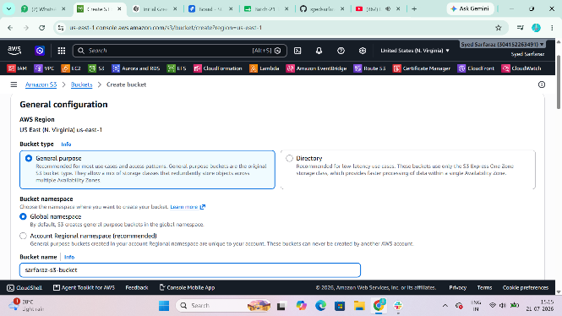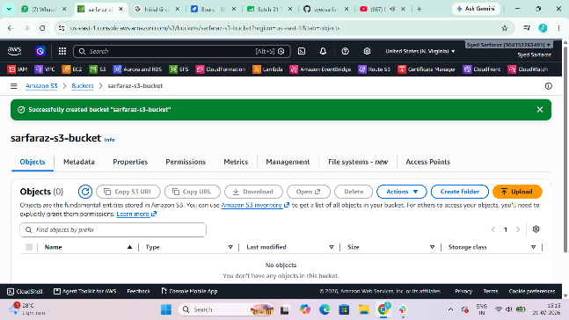
Step 3: Upload Objects
Open the bucket.
Click
Upload
Click
Add Files
Select
- sample.txt
- image.jpg
- document.pdf
Click
Upload
Wait until upload is complete.
📸 Evidence Screenshot 3
- Objects uploaded successfully
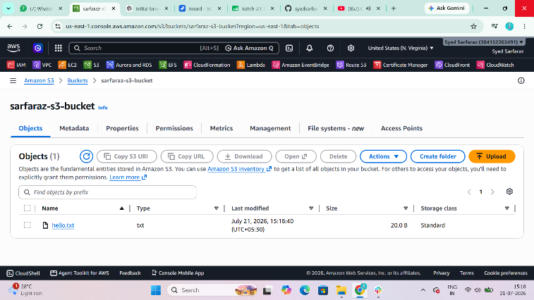

Task 2: Deploy a Static Website in S3
Purpose
Host a static HTML website directly from Amazon S3.

Step 1:
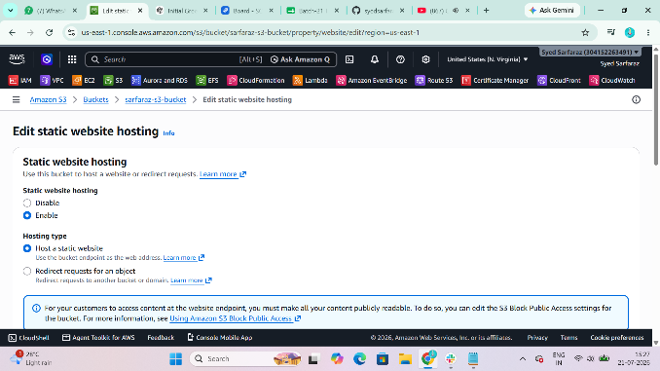

Step 2: Upload HTML
Open your bucket.
Click
Upload
Upload
index.html

Step 3: Enable Static Website Hosting
Inside Bucket
Go to
Properties
Scroll down.
Find
Static website hosting
Click
Edit
Choose
Enable
Hosting Type
Host a Static Website
Index document
index.html
Save Changes.

Step 4: Allow Public Access
Go to
Permissions
Edit
Block Public Access
Uncheck
Block All Public Access
Save.
Type
confirm
Save.
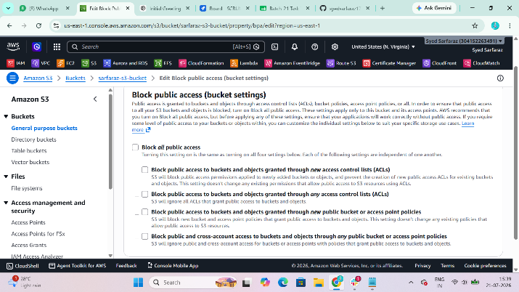

Step 5: Bucket Policy
Go to
Permissions
Bucket Policy
Paste
{
"Version":"2012-10-17",
"Statement":[
{
"Sid":"PublicReadGetObject",
"Effect":"Allow",
"Principal":"*",
"Action":"s3:GetObject",
"Resource":"arn:aws:s3:::YOUR-BUCKET-NAME/*"
}
]
}
Replace
YOUR-BUCKET-NAME
with your bucket name.
Save.
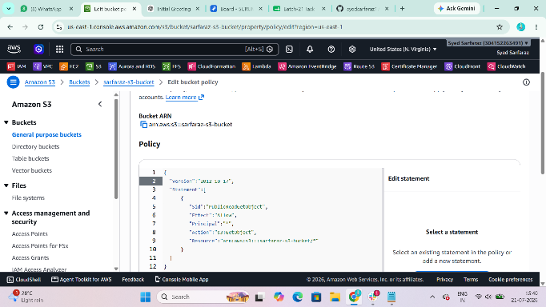

Step 6
Go to
Properties
Static Website Hosting
Copy
Bucket Website Endpoint
Open in browser.
Website loads successfully.
📸 Evidence
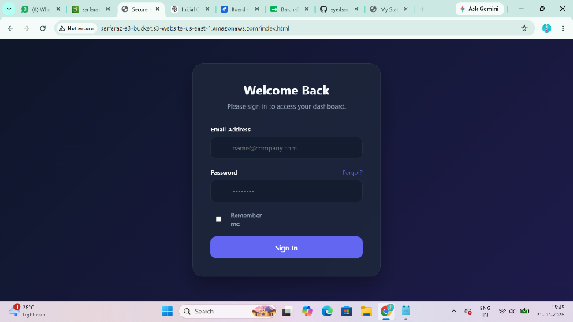

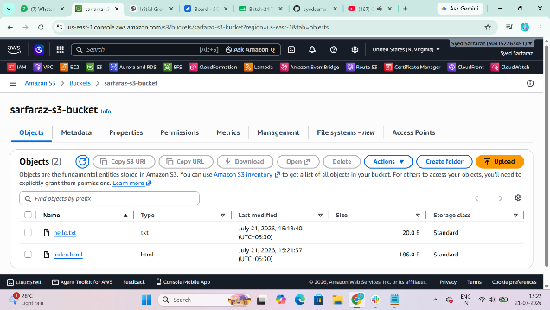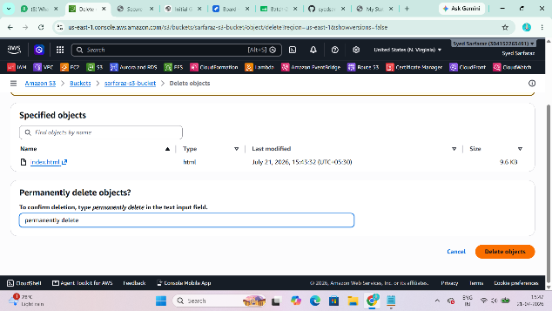
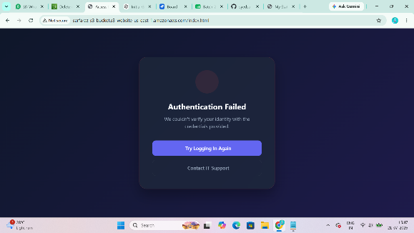

Task 3: Enable Cross-Region Replication
Purpose
Automatically copy objects from one S3 bucket to another bucket in a different AWS Region.

Step 1
Create another bucket.
Example
Source Bucket
sarfaraz-source
Region
us-east-1
Destination Bucket
sarfaraz-destination
Region
ap-south-1
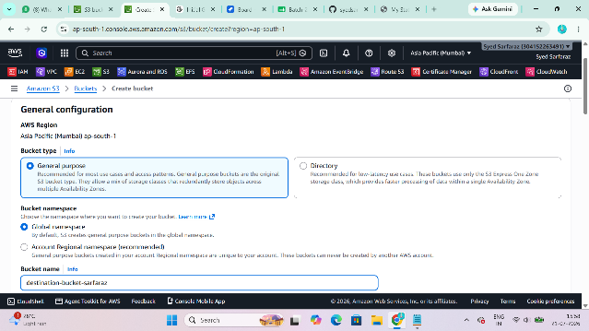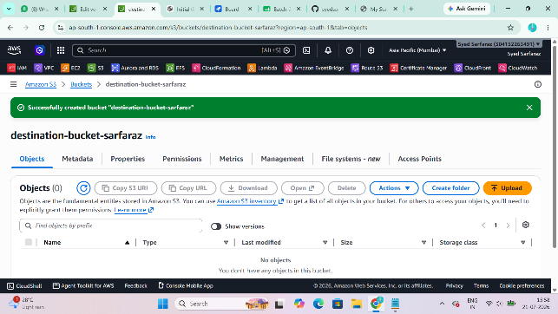

Step 2
Enable Versioning
Open
Source Bucket
Properties
Versioning
Enable
Repeat for Destination Bucket.
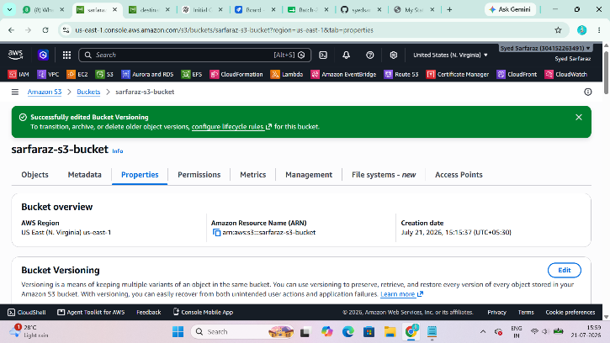

Step 3
Open Source Bucket
Management
Replication Rules
Create Replication Rule
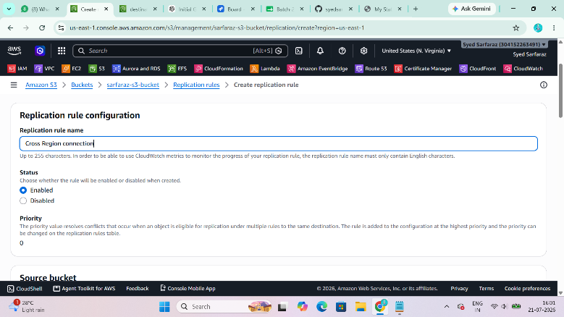

Rule Name
CrossRegionReplication
Status
Enabled
Choose
Entire Bucket
Destination
Choose Existing Bucket
Select Destination Bucket.
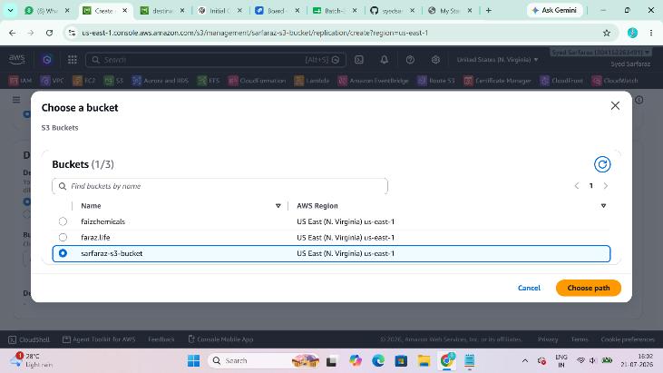

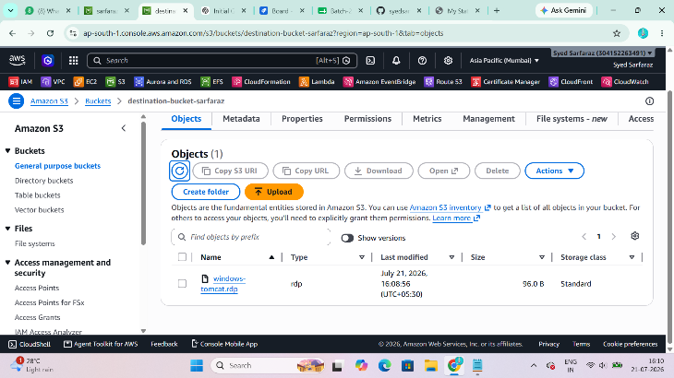
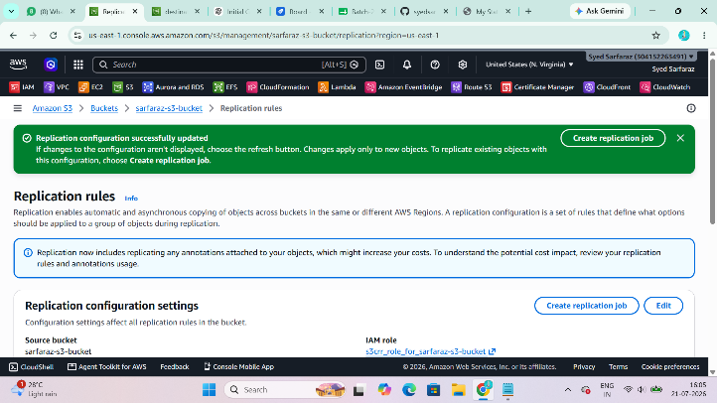

Choose
Create New IAM Role
AWS creates role automatically.
Click
Save.
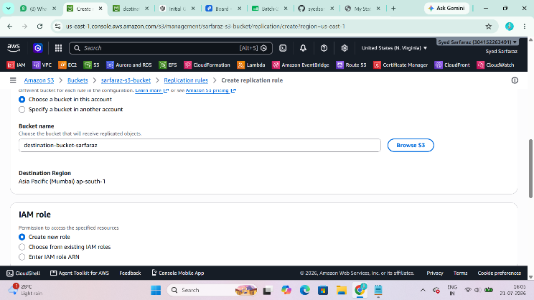

Upload one file into source bucket.
After few seconds
Check destination bucket.
Same file appears.
📸 Evidence
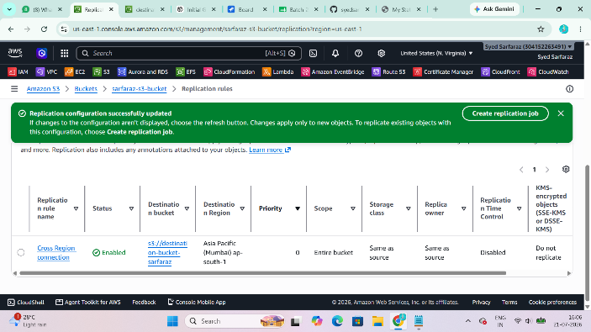

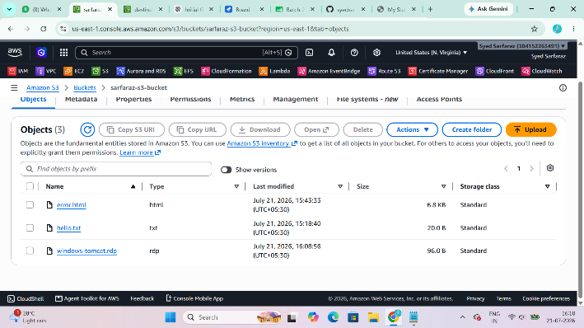

Task 4: Bucket Policy (Only Admin User Can View Objects)
Purpose
Restrict access so only a specific IAM Admin user can list and read objects in the bucket.

Step 1
Identify the IAM Admin user's ARN.
Go to IAM → Users → Admin and copy the ARN, for example:
arn:aws:iam::123456789012:user/Admin
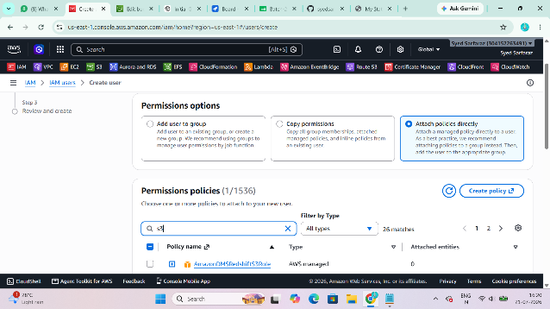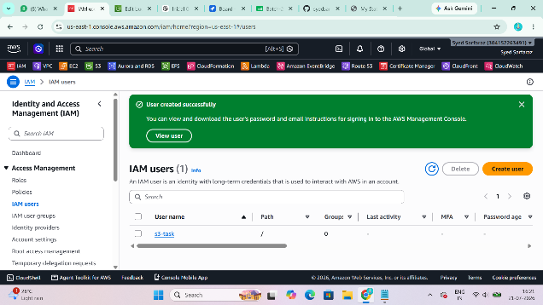

Step 2
Open the S3 bucket.
Go to:
Permissions → Bucket Policy
Replace the account ID and bucket name in the following policy:
{
"Version": "2012-10-17",
"Statement": [
{
"Sid": "AllowOnlyAdminUser",
"Effect": "Allow",
"Principal": {
"AWS": "arn:aws:iam::123456789012:user/Admin"
},
"Action": [
"s3:ListBucket"
],
"Resource": "arn:aws:s3:::YOUR-BUCKET-NAME"
},
{
"Sid": "AllowAdminReadObjects",
"Effect": "Allow",
"Principal": {
"AWS": "arn:aws:iam::123456789012:user/Admin"
},
"Action": [
"s3:GetObject"
],
"Resource": "arn:aws:s3:::YOUR-BUCKET-NAME/*"
}
]
}
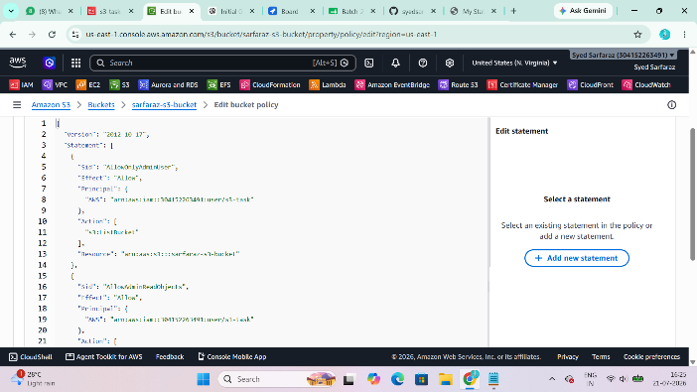
Note: If other IAM users already have broad s3:* permissions (for example through AmazonS3FullAccess), this bucket policy alone may not prevent them from accessing the bucket. Your instructor may expect a combination of IAM permissions and bucket policy for strict access control.
📸 Evidence
- Bucket policy
- Admin user successfully viewing objects
- Other user denied access (if tested)

Task 5: Configure Lifecycle Policy
Purpose
Automatically transition or delete objects after a specified period to reduce storage costs.

Step 1
Open the S3 bucket.
Go to:
Management → Lifecycle rules → Create lifecycle rule
Step 2
Enter:
Field | Value
Rule Name | DeleteOldObjects
Scope | Apply to all objects
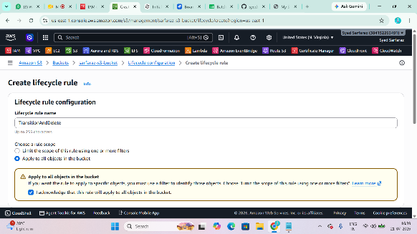 | 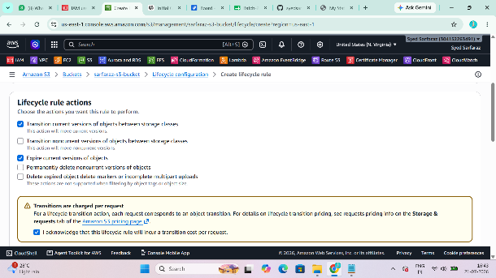
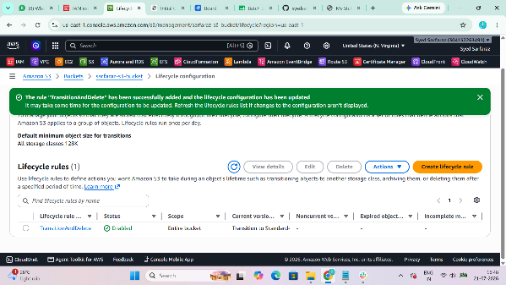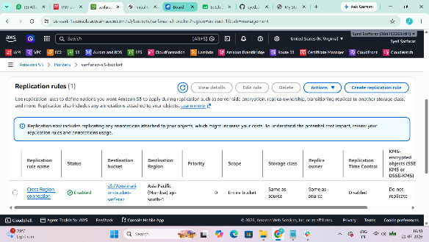
Step 3
Under Lifecycle rule actions, select:
- Transition current versions of objects between storage classes (optional)
- Expire current versions of objects
Example:
- Transition to Standard-IA after 30 days
- Permanently delete after 365 days
Click Create rule.
📸 Evidence
- Lifecycle rule configuration

Task 6: Upload Objects Using AWS CLI
Purpose
Upload files to S3 from the command line.

Step 1
Check AWS CLI:
aws --version
Step 2
Configure credentials (if not already configured):
aws configure
Provide:
Access Key
Secret Key
Region
Output format
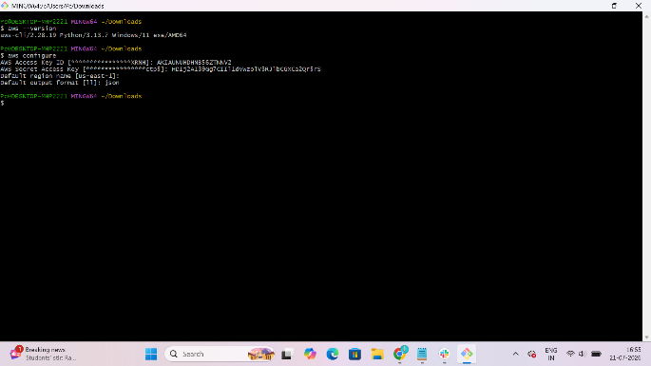
Step 3
Upload a file:
aws s3 cp sample.txt s3://YOUR-BUCKET-NAME/
Upload an entire folder:
aws s3 cp ./myfolder s3://YOUR-BUCKET-NAME/ --recursive
Verify:
aws s3 ls s3://YOUR-BUCKET-NAME/
📸 Evidence
- Upload command
- aws s3 ls output
- Bucket showing uploaded objects
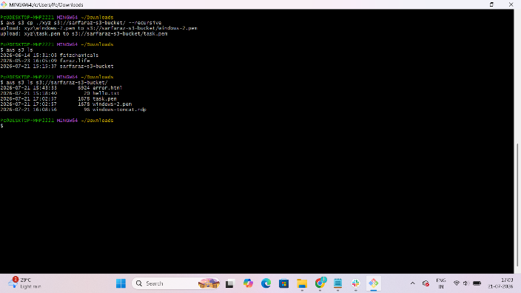

Task 7: Write a Bash Script to Create an S3 Bucket
Purpose
Automate S3 bucket creation.
Create a file:
vi create_bucket.sh
Paste:
#!/bin/bash

BUCKET_NAME="sarfaraz-bucket-001"
REGION="us-east-1"

aws s3api create-bucket \
--bucket $BUCKET_NAME \
--region $REGION
Save and exit.
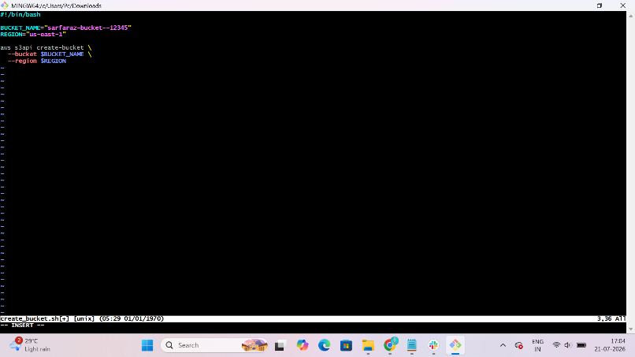

Make it executable:
chmod +x create_bucket.sh

Run:
./create_bucket.sh
Verify:
aws s3 ls
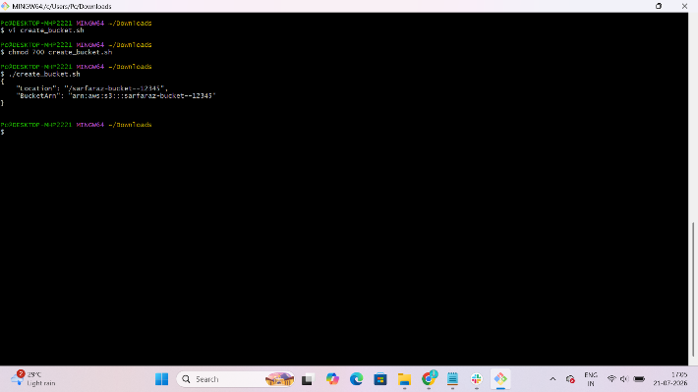
📸 Evidence
- Script file
- Script execution
- Bucket listed in S3
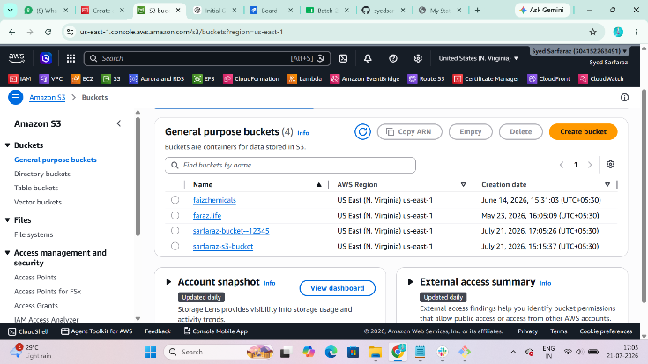

Task 8: Upload a 1 GB File Using AWS CLI
Purpose
Upload a large file to S3 using the AWS CLI.
Step 1: Create a 1 GB file
On Amazon Linux:
fallocate -l 1G largefile.bin
If fallocate is unavailable:
dd if=/dev/zero of=largefile.bin bs=1M count=1024
Verify the size:
ls -lh largefile.bin
Step 2: Upload the file
aws s3 cp largefile.bin s3://YOUR-BUCKET-NAME/
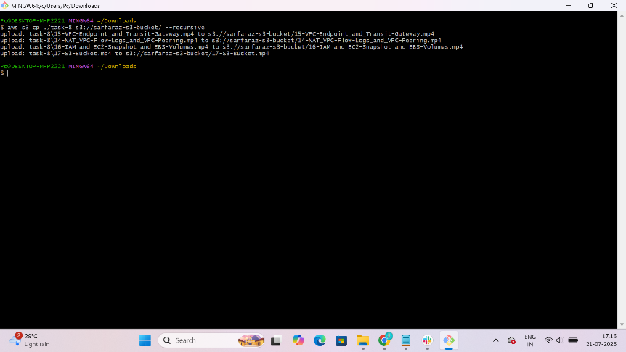
Step 3: Verify the upload
aws s3 ls s3://YOUR-BUCKET-NAME/
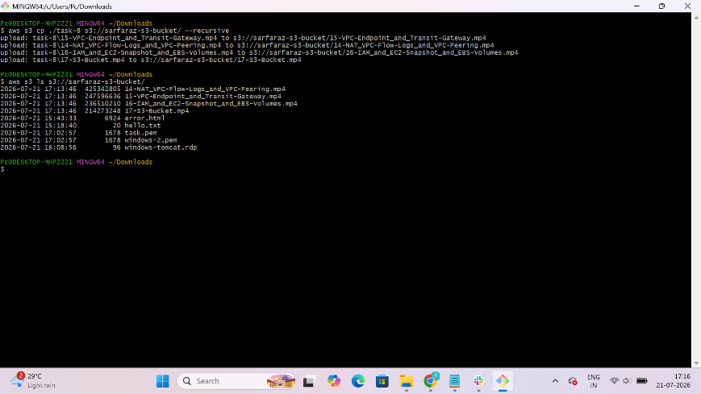
📸 Evidence
- 1 GB file created
- Upload command
- Successful upload shown in the bucket
